**Assinment-1**

**Write a query to get a Product list (id, name, unit price) where current products cost less than $20.**

select ProductID , ProductName , UnitPrice where UnitPrice < 20

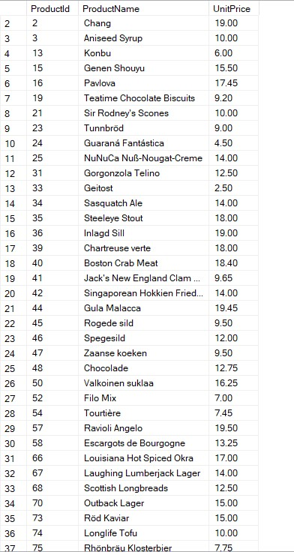

**Write a query to get Product list (id, name, unit price) where products cost between $15 and $25**

select ProductId , ProductName , UnitPrice from Products where UnitPrice between 15 and 25

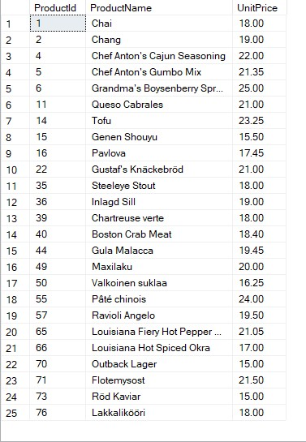

**Write a query to get Product list (name, unit price) of above average price.**

select ProductName,UnitPrice from Products where UnitPrice > (select AVG(UnitPrice) from Prodects)

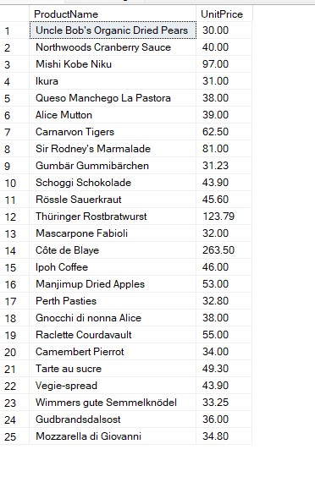

**Write a query to get Product list (name, unit price) of ten most expensive products**

select top 10 ProductName , UnitPrice from Products Order By UnitPrice DESC

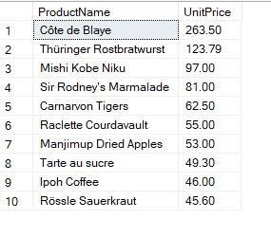

**Write a query to count current and discontinued products**

select COUNT(Discontinued) from Products where Discontinued = 1

select COUNT(Discontinued) from Products where Discontinued != 1

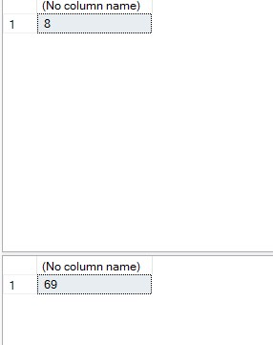

**Write a query to get Product list (name, units on order , units in stock) of stock is less than the quantity on order**

select ProductName , UnitsOnOrder , UnitsInStock from Products where UnitsInStock < UnitsOnOrder

